Mr. and Mrs. Wilkinson’s Financial Plan

“Exceeding your financial expectations”

Provided by the listed financial planners: Mira Qutub, Michael Oravetz, Ali Alam, Stuart Weaver
Table of Contents
Our Obligation 3
4 E's 3
Fee Structures 4
Financial Record Keeping 4
Where to store your financial records? 6
Refinancing your home 6
Insurance 10
Paying off your Debt 11
Year-End Net Worth Statement 13
Annual Cash Flow Statement 15
Financial Ratios 16

Our Obligation
Here at Winston Financial Company we take pride in being fiduciaries. Being a fiduciary is a responsibility that Certified Financial Planners (CFP’s) have where they put a client’s interests before their own. This is extremely crucial because we go above and beyond to make sure our clients have a sense of trust with us. It also puts our client at ease knowing that their CFP isn’t trying to manipulate them into spending more money than they should have too or not worrying that their financial planner is only in it for the commission.

4 E’s
In order to become a Certified Financial Planner, the individual has to meet the initial certification requirements known as the “4 E’s” (Education, Examination, Experience, and Ethics).

Starting with education certified financial planners must obtain a college-level program with a concentration in financial planning or something of that sort. Although, it helps to obtain a bachelors degree it is not required to take the CFP examination. After you finish education then comes examination, this is where you apply what you learned in school to real-life situations. Once you completed the examination then you have to gain experience. A CFP must have three years of professional experience.
Lastly is ethics, which is where the CFP professionally agrees to obey the standard of ethics and financial planning practice outlined in the CFP Board’s Standards of Professional Conduct.

Fee Structures
Financial Planners may choose four different ways to charge their client.
- Fee Only – hourly rate charged to a client for the services provided
- Fee Based – percentage fees based on some aspect of the client’s financial profile
- Commission Only – commission generated from a product or service
- Fee-Offset – performance based fees, related to the profitability of the client’s invested assets

Financial Record Keeping
Being curious about financial record keeping for your important documents is completely normal. You should start by collecting important papers and documents throughout your house. According to the IRS, “the length of time you should keep a document depends on the action, expense or event the document records”. “Generally, you should keep records that support an item of income or deductions on a tax return until the period of limitations for that return runs out”.
(http://www.irs.gov/Businesses/Small-Businesses-&-Self-Employed/How-long-should-I-keep-records).
The table below provided by Suze Orman Resource Center categorizes how long you should keep the following documents. (http://www.suzeorman.com/resource-center/record-keeping/).
1 Year | Paycheck stubs | Utility bills | Credit card receipts | Bank Statements | Quart invest.  Statements | Cancelled Checks
3 Years | Income tax returns | Medical bills and cancelled insurance policies | Records of selling a house/stock | Receipts, cancelled checks | Documents that support income or deduction on tax return | Annual investment statement
7 Years | Records of satisfied loans
Hold while active | Contracts | Insurance documents | Stock certificates | Property/stock records and home improvement records | Records of pensions and retirement plans | Property tax records disputed bills
Keep forever | Marriage licenses | Birth certificates | Wills | Adoption papers | Death certificates | Records of paid mortgages
Where to store your financial records?

There are also three different ways you can store these important documents. The first way is to keep hard copies; although this is old fashioned you can still use this method as a backup. The second is using online storage, which is convenient because you can pull up your records with any computer with Internet connection. The last way is storing your records on your own hard drive and this method is extremely reliable because your files will be backed up.

(http://money.usnews.com/money/blogs/my-money/2011/01/20/where-to-keep-your-important-financial-records).

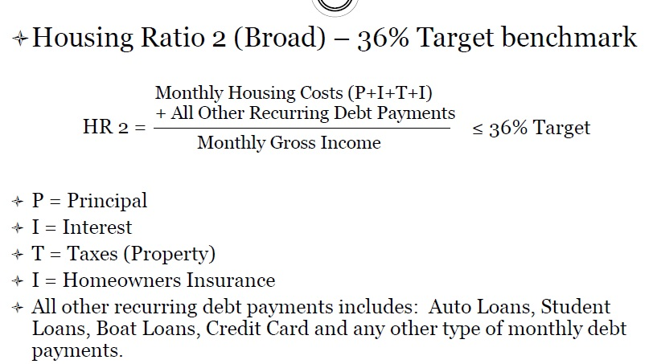
Refinancing your Home
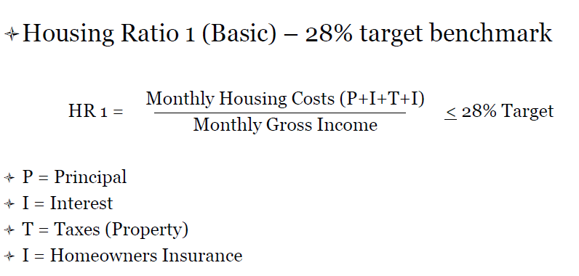
Decision 1
PV 183,500
N 180 (15*12)
I/Y .35 (4.2/12)
FV 0
PMT $1,376
Annual payment $16,510

$247,643 over 15 years ($64,143 in interest expense)
Housing Ratio 1 = ($1,376/$14,000) = 12.69%
Housing Ratio 2 = ($1,376+$1,578)/($14,000) = 23.96%

Pros
Paid off sooner

Cons
Expensive in the short term
Expensive payment
Decision 2
PV $183,500
N 360 (12*30)
I/Y .38 (4.6/12)
FV 0
PMT $941

Annual payment $11,288

$338,653 Over 30 years ($155,154 in interest expense)

Housing Ratio 1 ($941/$14,000) = 6.72%
Housing Ratio 2 ($941+$1,578)/($14,000) = 17.99%

Pros
Paying less per month
Cons
Longer to pay off and expensive cost over long term
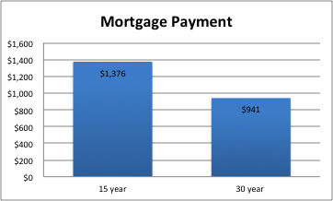
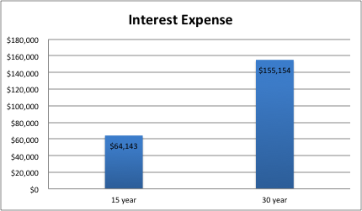
Insurance
The Split Limit Policy that Todd and Sarah have is a $50k/$100k/$50k with a $500 deductible. This means that the insurance policy will cover $50k per person of injury cost and up to a total cost of $100k. If the injuries of a single person are less than $50k then the entire cost of the medical expenses will be covered. If it exceeds this limit then Todd and Sarah will be liable for the rest. Also if there are multiple people that get injured in an accident and the total for injury cost is higher than $100k, then Todd and Sarah will once again be liable for the rest. If Todd and Sarah can afford it, raising this limit or switching to an umbrella policy is strongly recommended.

The $50k at the end of the Split Limit is the amount of property damage that the policy covers. This will cover damage to a home, car, or any other property that Todd and Sarah damage. Similar to the Liabilities for bodily injuries, Todd and Sarah will be liable for any cost that exceeds the policy limit. Same as before, raising this limit or switching to an umbrella policy would provide greater protection.

Todd and Sarah have 100% of the actual cash value of the home insured along with cost coverage on their property. This means if the home burns down or is totaled for some reason, the insurance company covers the entire cost of the home and property inside. This is the best home insurance you can get, and cannot advise any better.
Paying off your Debt
Under the current plan according to Power Pay, it would take you 9 years and 9 months to pay off all Debt by just making the minimum payments. If you combine all of the minimum payments and commit to spending that amount until all the debt is paid off, you drastically reduce the time required to pay off the total debt.

As seen in Payment Calendar 1, if paying the combined amount for the extent that you have debt, you reduce the payoff time to 6 years flat. If the Wilkinson’s are able to afford to include the extra $300 a month, then the Payment Calendar can be further reduced to 5 years flat. This is shown in Payment Calendar 2.
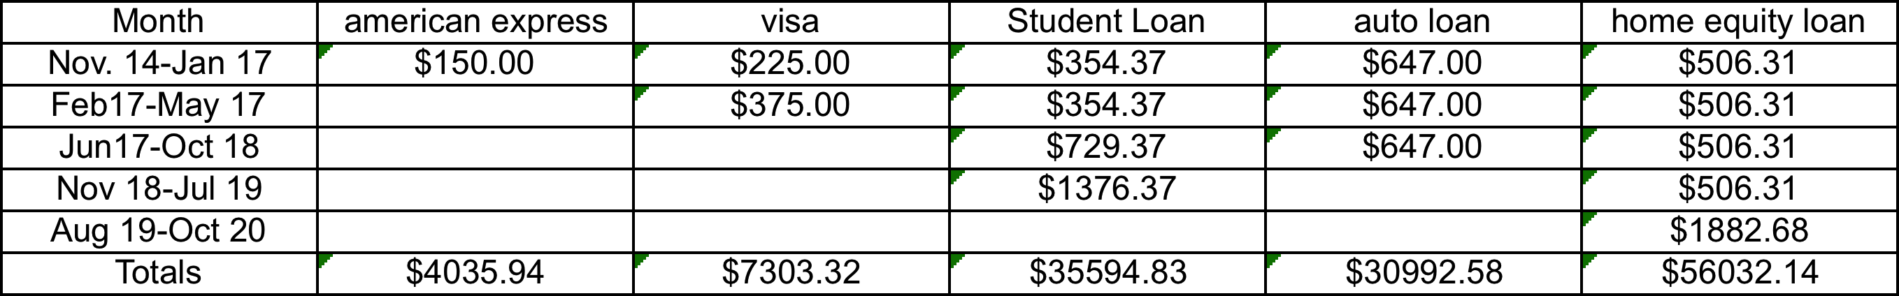
When including the extra $300 into the payment calendar it is recommended to add this money onto the debt with the highest interest payment. For the Wilkinson’s this is the Visa Credit Card. By adding the extra $300 onto the Visa Card Debt, the total savings in interest payments are $10057.51, rather than $6254.31 through the first payment calendar. By paying off the largest debt first, the Wilkerson’s will minimize the amount of interest they are paying, and save a greater total amount.
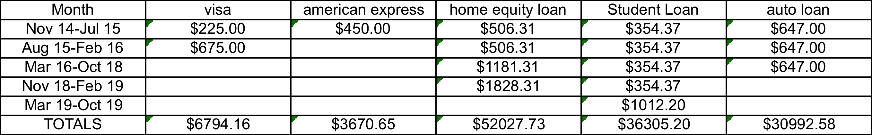

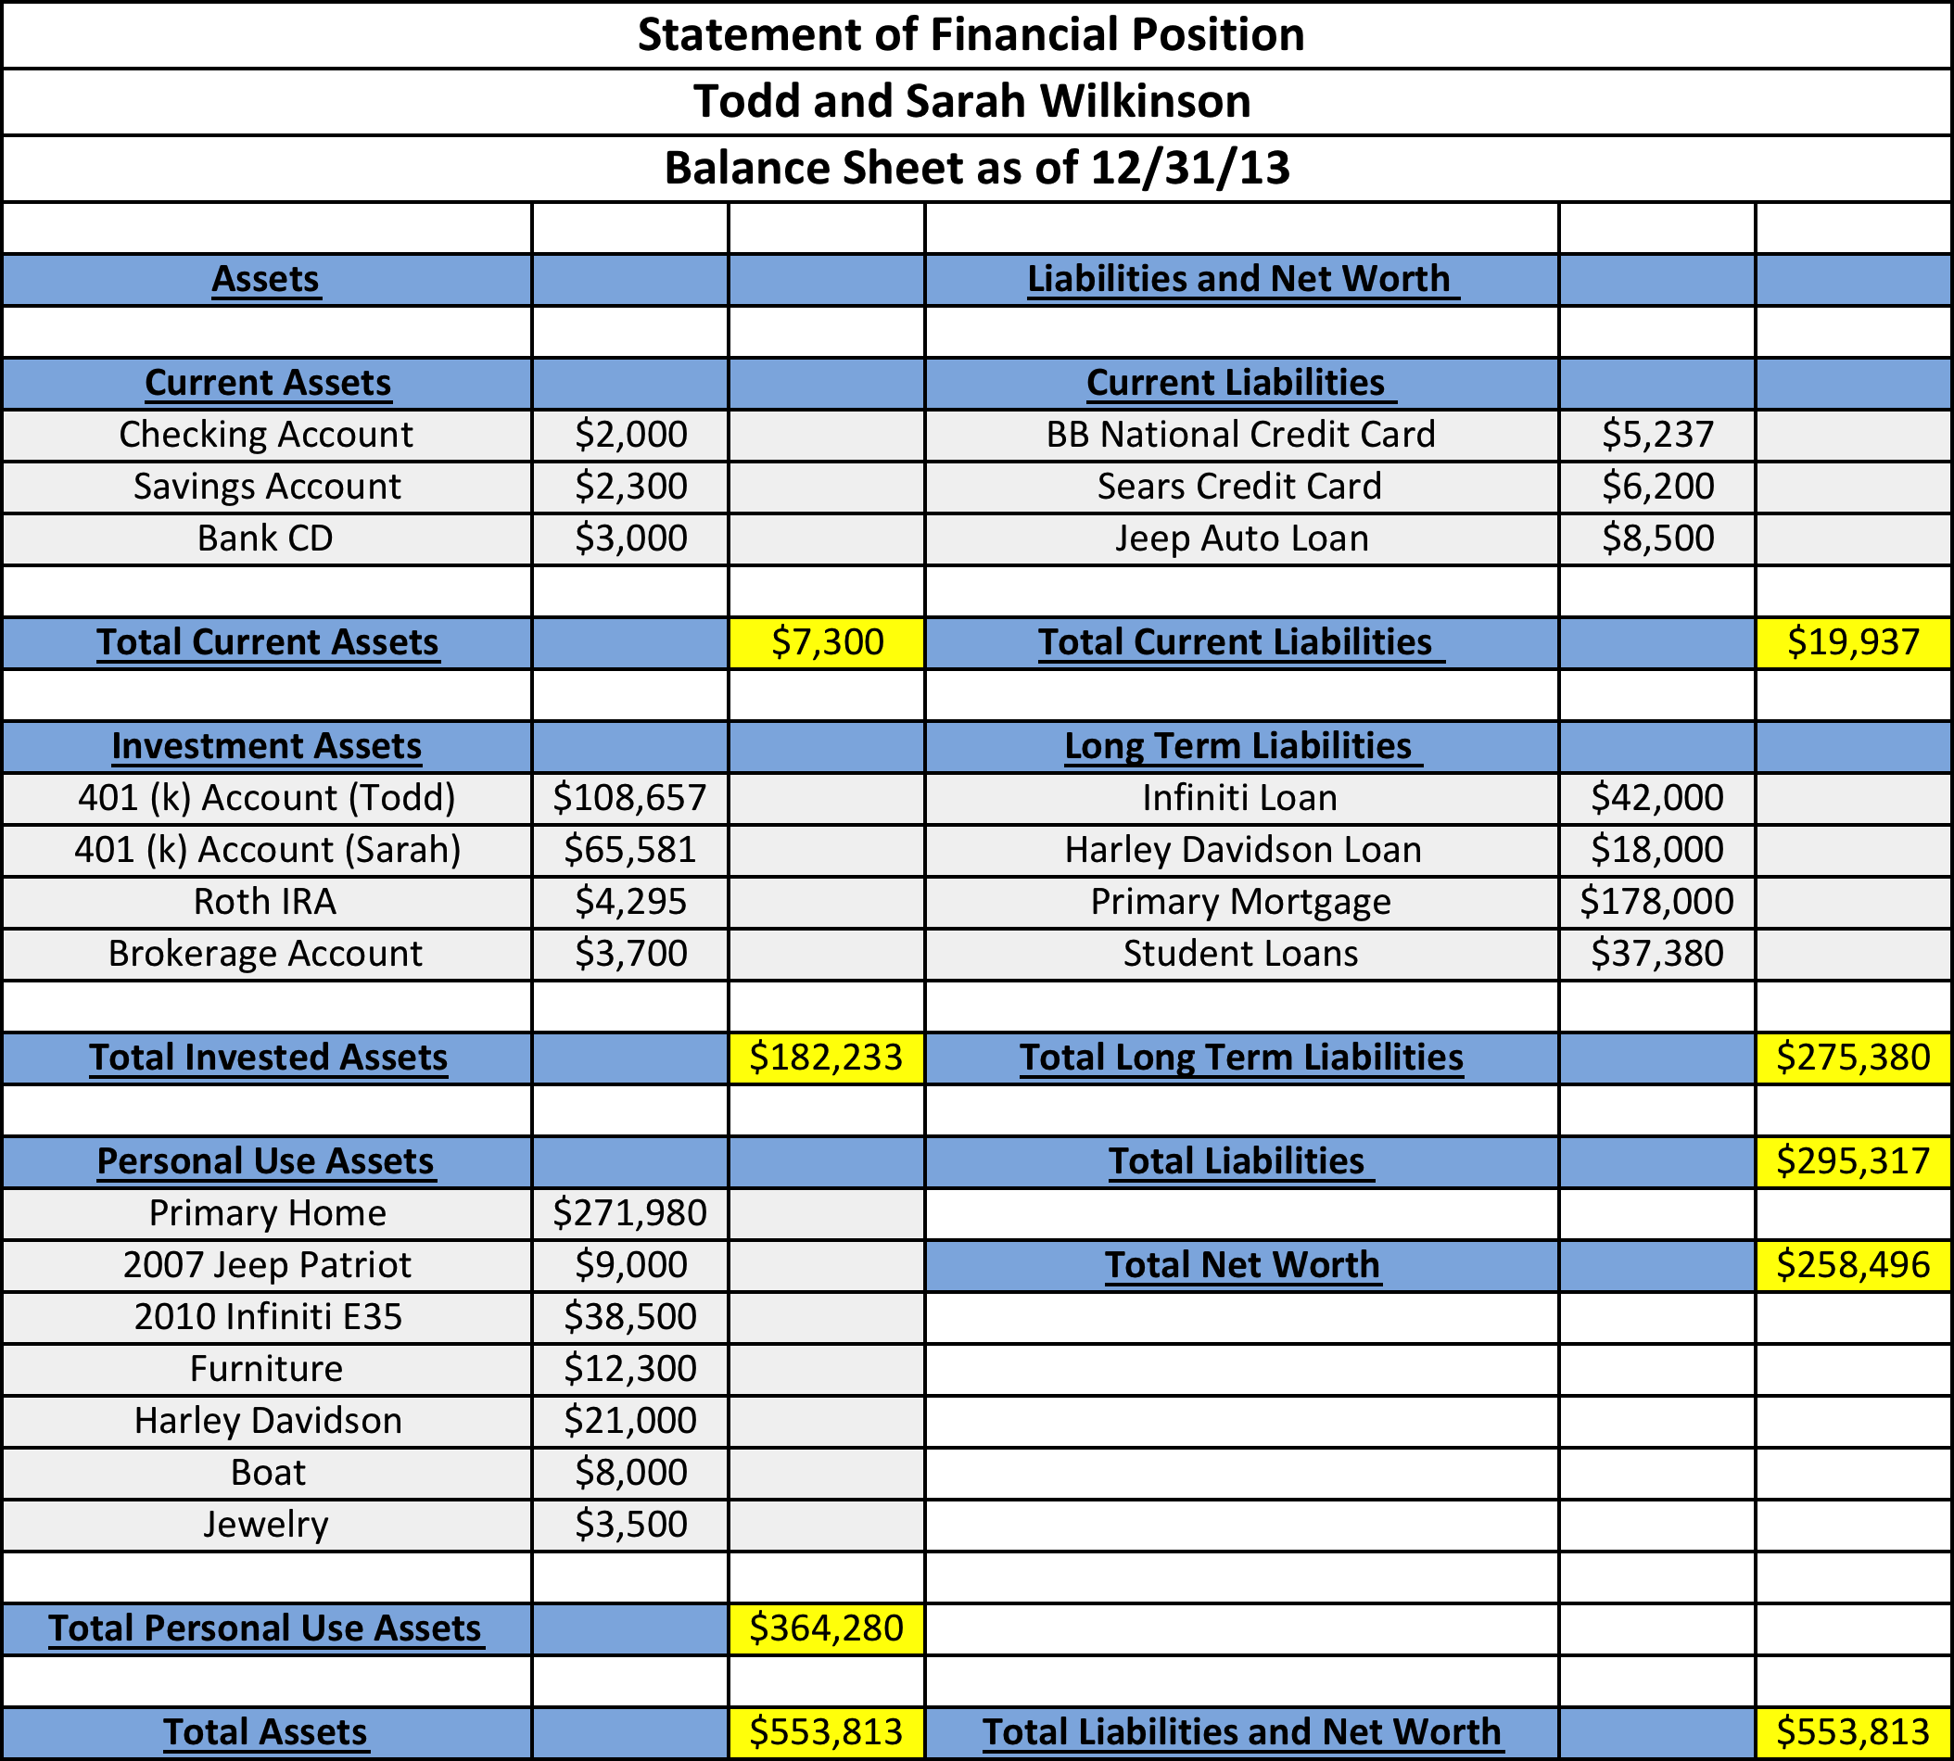
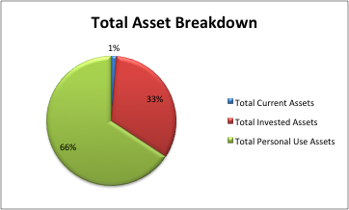

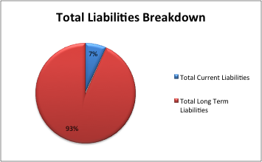
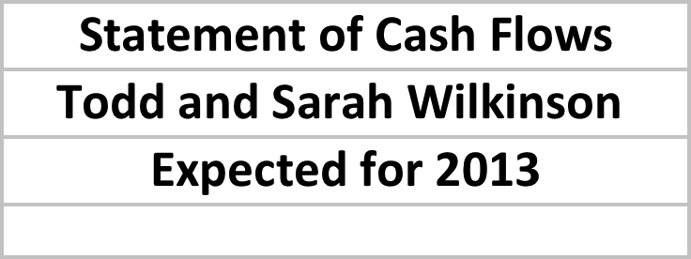
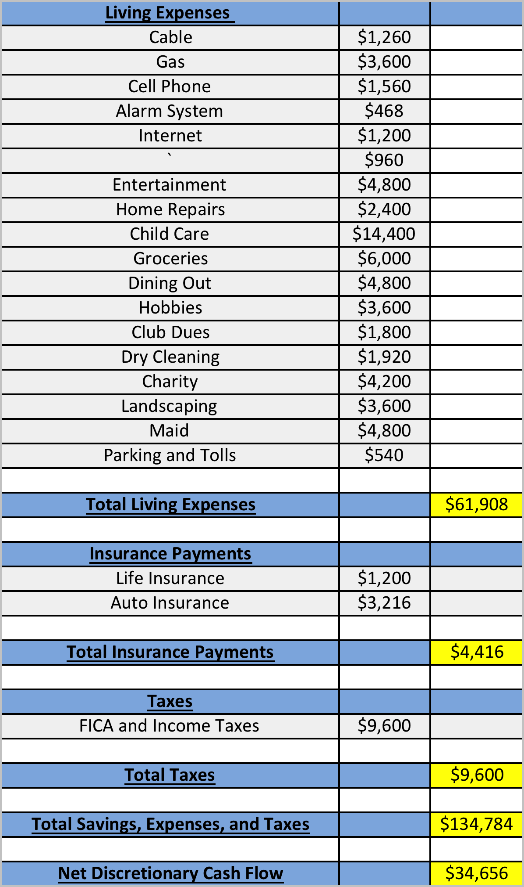
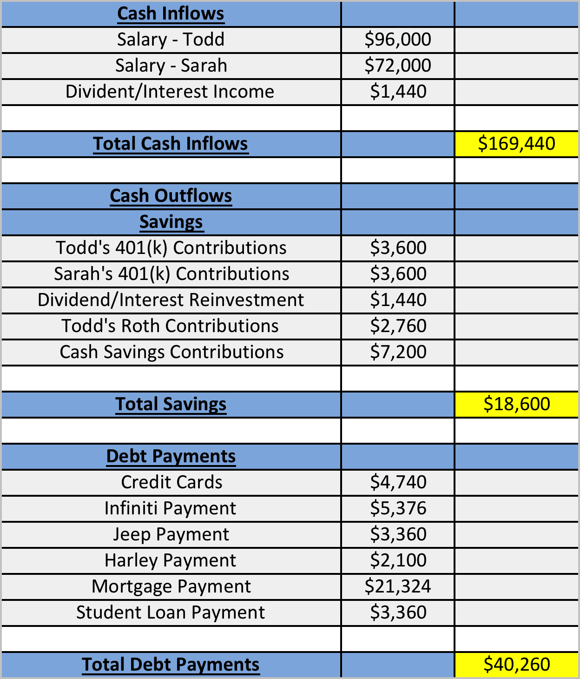
Financial Ratios
Liquidity Ratios
Current Ratio –Cash+ Cash equivalents/Current liabilities
2000+3000/19,937 =.25

Emergency – Cash+ Cash equivalents/Non- Discretionary expenses (monthly)
2000+3000/6042=.83
[(Gas + alarm system+ water+ home repairs+ child care groceries+ life insurance+ auto insurance + mortgage payment+ jeep payment+ Harley payment+ infinity payment+ student loan payment+ credit card payment)]/12 = Monthly Nondiscretionary income

Debt Ratios
Debt to Asset Ratio- Total Debt/Total Assets
295317/553813=53%

Net Worth to Total Asset Ratio- Net worth/Total Assets
258496/553,813=47%

Financial Security Ratios
Savings Rate – (Savings + Employer Match)/ Gross Payment
11,400/169,440=7%

Investment Asset to Gross Payment –
[(Investment Assets) + (Cash + Cash Equivalents)]/ Gross Payment
182,233+5000/169440= 1.11

Conclusion from Ratios

Strength
• The Housing Ratios 1 and 2 are both beneath the required threshold, meaning either option is viable.
• The Debt to Total Asset and Net worth to Asset ratio should be considered over time to monitor your progress
Weaknesses
• Current Ratio should be between 1 and 2. A decrease in Current Liabilities and or an increase in Cash and Cash equivalents would increase this ratio.
• The Emergency Fund Ratio should be between 3 and6 months, an increase in Cash and Cash equivalents will increase this ratio
• Savings Rate should be increased to between 10 and 13%. An increase in savings contributions would increase the savings rate
• Investment Assets to Gross Payment should be increased to a range between 1.6-1.8:1depending on your age. An increase in Investment Assets, Cash or Cash equivalents will increase the ratio.

